20/12/2023

Chakradhar Bhogapurapu, BIBA

Python Assessment

Question 1

Explain Python Module with examples

Ans

Modules are a type of file that is used to import into another python file to reuse the functions in the specific module. Generally, module is a collection of functions and they can be reused by importing.

Syntax : import module_name

There are user defined modules and also built in modules.

🡪User defined modules

These modules are created by the user. They can be reused by importing them into the desired python file. 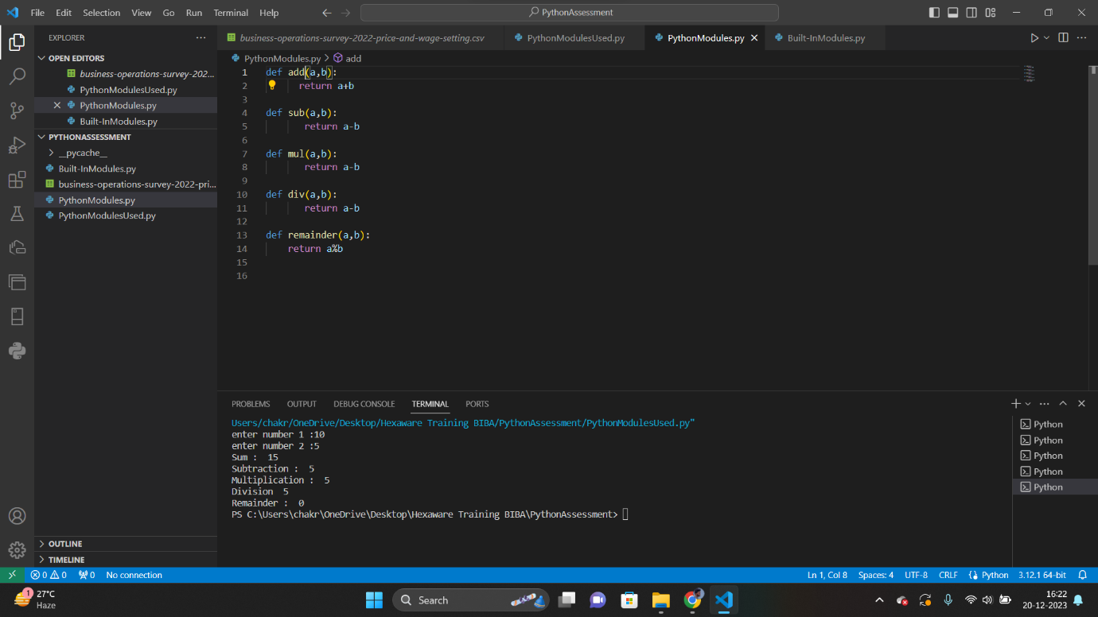

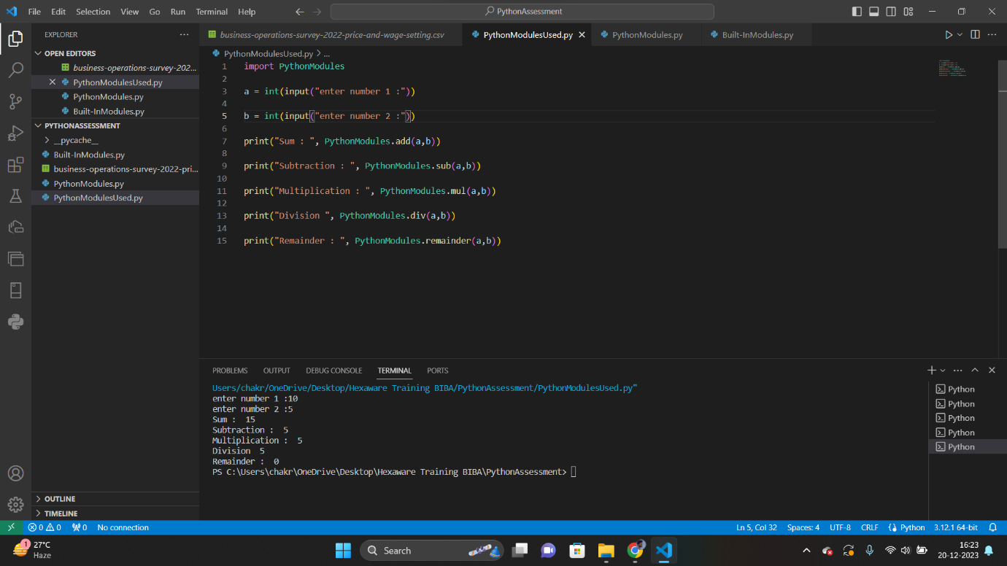

From the above example we can see that, “PythonModule.py” is a python file that has some functions in it. This file is imported into the “PythonModuleUsed.py” file to use the functions present in it.

🡪Built-In Modules

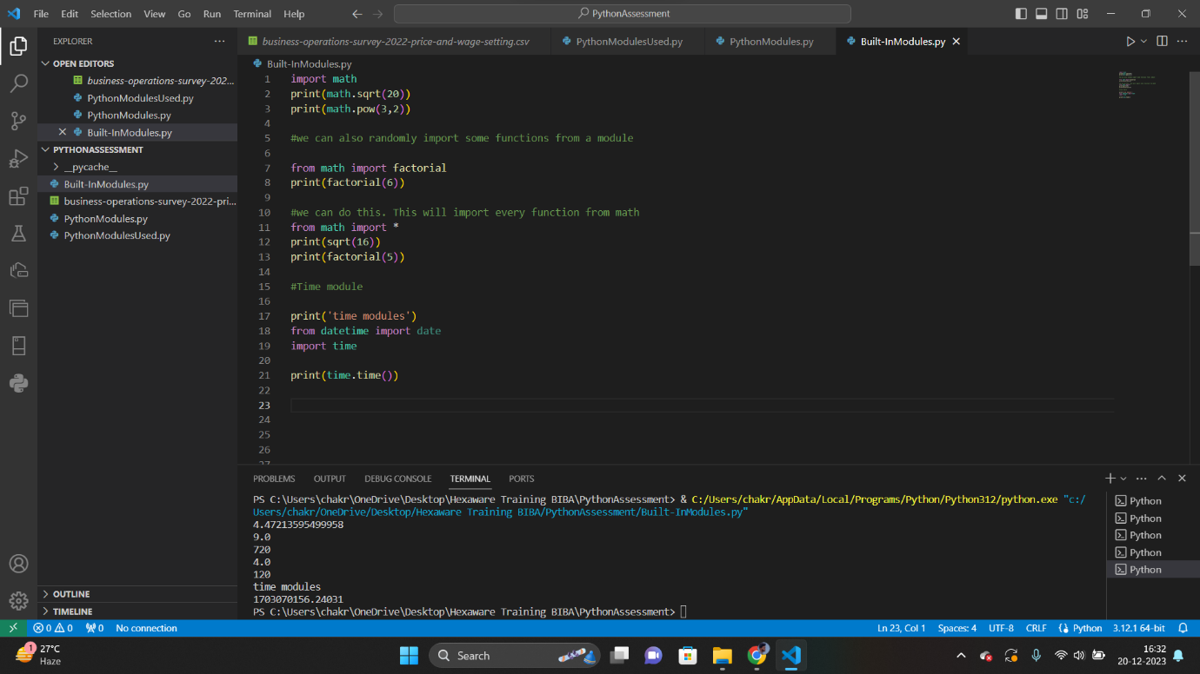

Modules that are already exist in python are known as built-in modules.

Eg : math module.

From the above example we can see that math module is imported. We use * to import every function from the module and can use them easily. We can also import specific functions from the module.

There is also inbuilt time module in python, that shows the present time.

🡪Renaming the python module.

Syntax : import module_name as renamed_module_name

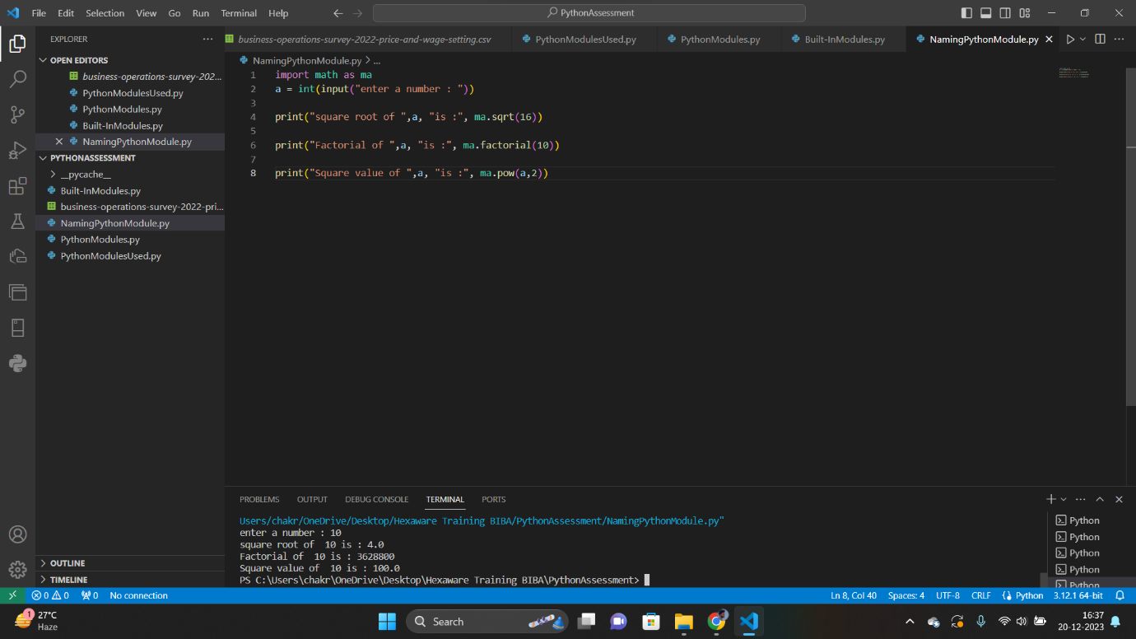

From the above example, we can see that math function is renamed as “ma”. And then we can get the functions from the math module with the name “ma”.

Eg : ma.sqrt(16)

Question 2

Explain Pandas and numpy using Examples in PYTHON

🡪Pandas

Pandas is an inbuilt python library that is used to work the data sets. Pandas are used to manipulate data. Pandas are used to fetch the data from the external csv file and also it can create a new csv file.

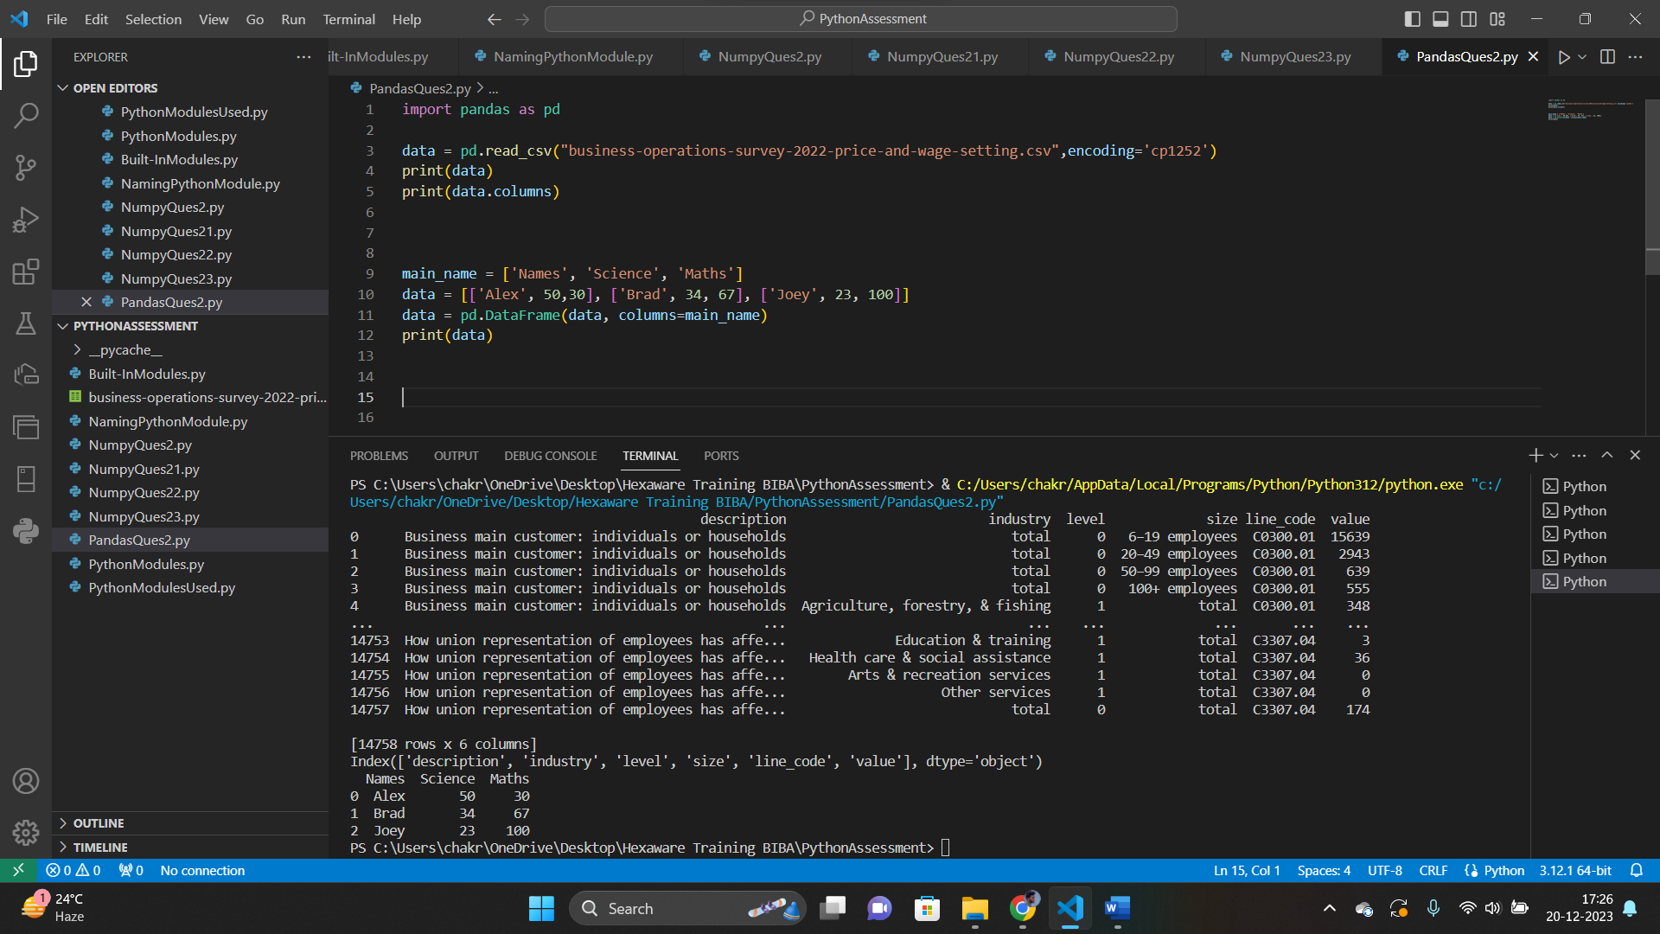

🡪Numpy

Numpy stands for NumericPython. Numpy is a python library that is used to manipulate arrays. It is used to solve algebraic expressions, Matrices, etc.

We import numpy into our python file as,

Syntax: import numpy

We can change the name of the module in our python file while importing.

Eg : import numpy as np

Here “np” is a user given name that are used to access the module easily.

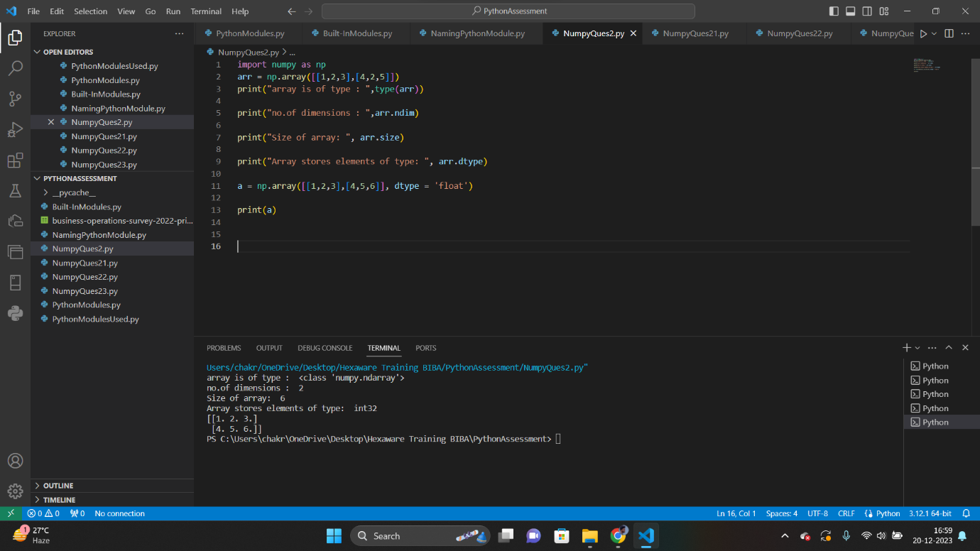

We can get the type of array by , type(arr). Here “arr” is the name of array.

Also we can get the dimensions of the array with “ndim”.

We can get the size of array with “size”.

We can get the data type of elements of array with “dtype”.

We can also give the data type of elements when we initialize the array as shown in above example.

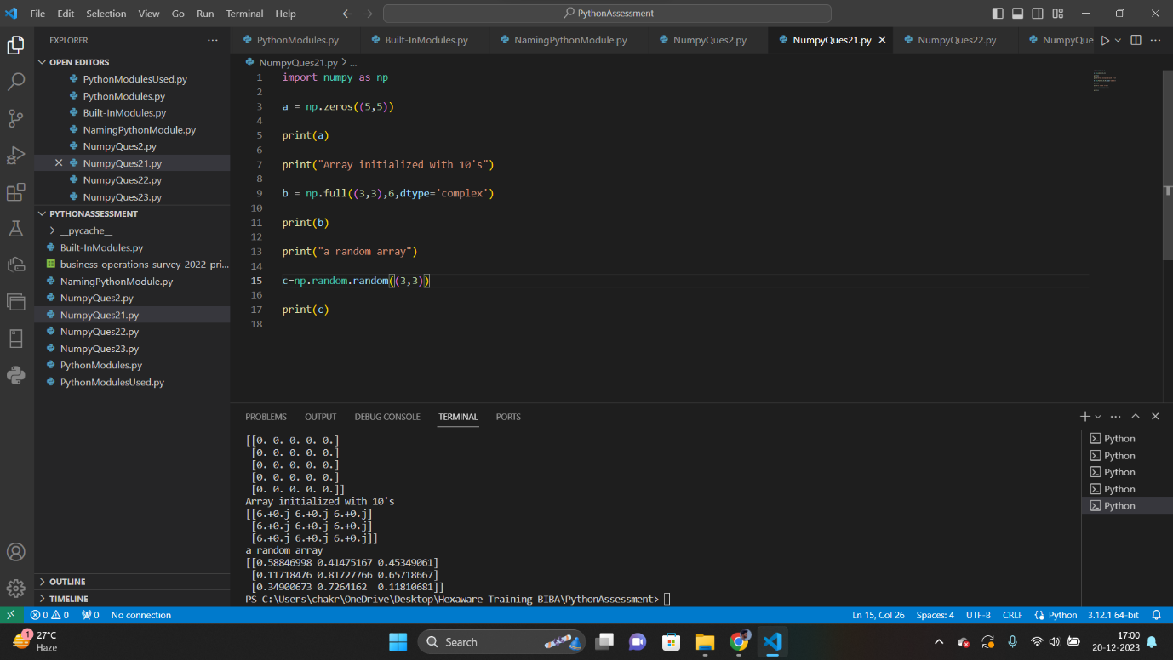

We can initialize a matrix with all zeros by giving the size as an input as shown in above example.

We can initialize the matrix with complex numbers by giving the values and size as an input.

We can create the random matrix by using “random” function that is present in numpy library.

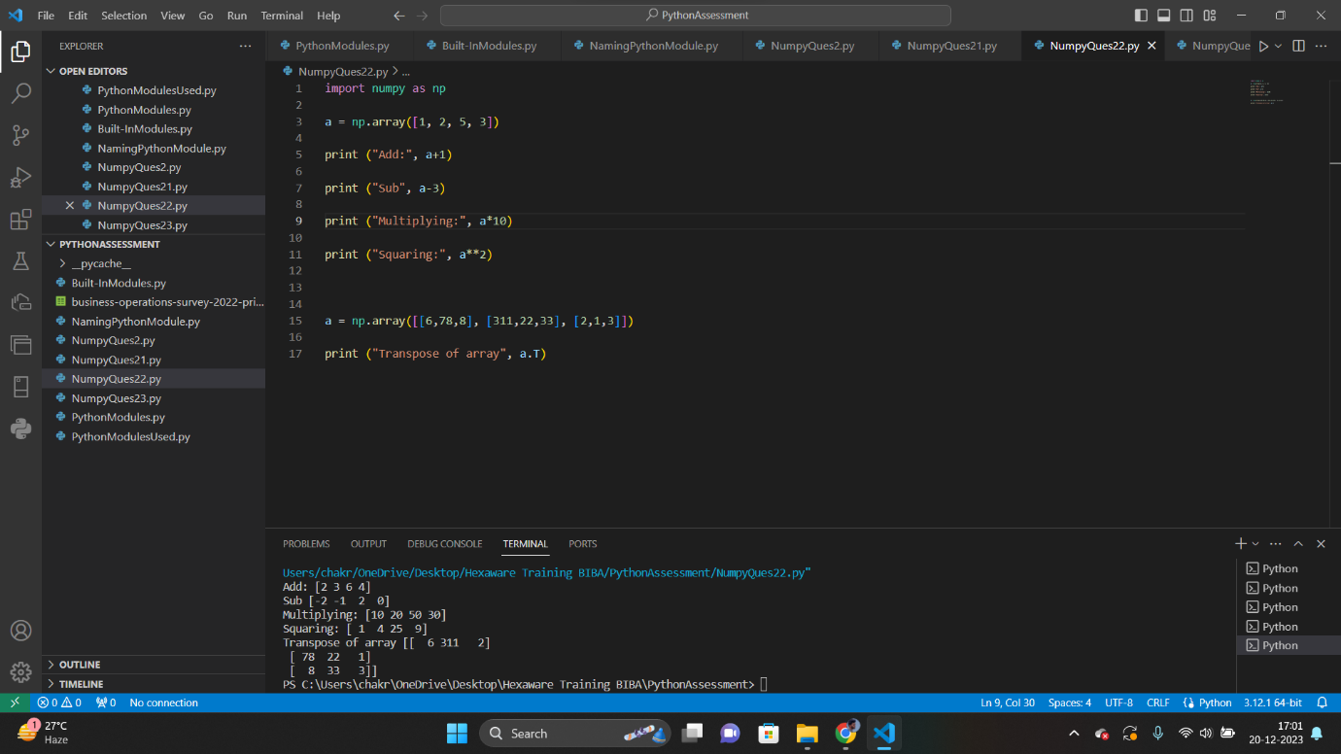

We can also do mathematical operations to the array.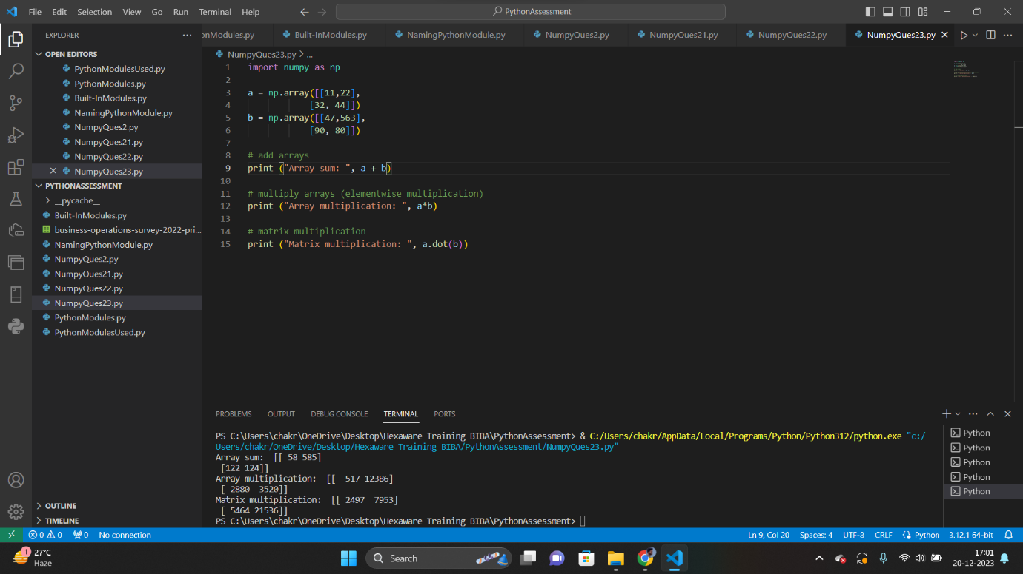

We can do mathematical operations on two arrays.